**INDUSTRIAL TRAININGREPORT**

**On**

**E-commerce website development**

**Submitted by**

**Name of Student: kamlesh yadav**

**Roll No: 181500304**

Department of Computer Engineering & Applications

**Institute of Engineering & Technology**



**GLA University**

**Mathura-281406,**

**(U.P) INDIA**

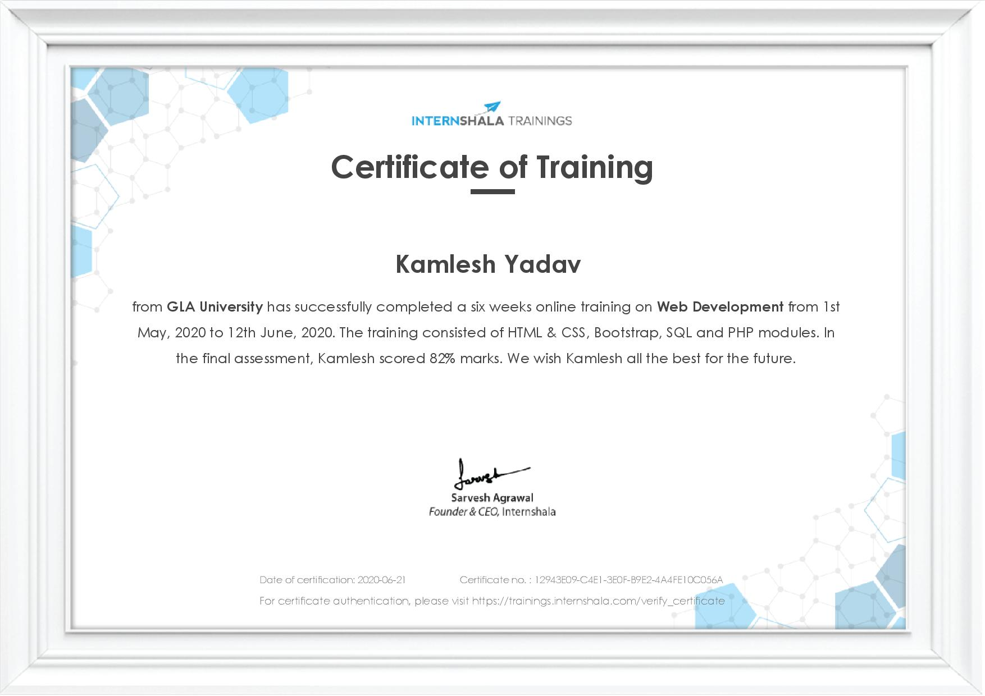

**Synopsis**

**Student Information:**

|  |  |
| --- | --- |
| Name: Kamlesh yadav | University Roll. No. 181500304 |
| Mobile: 9129106869 | Email: kamlesh.yadav_cs18@gla.ac.in |

**Information about Industry/Organization:**

|  |  |
| --- | --- |
| Industry/Organization Name with full Address | Intershala  Gurgaon , India |
| Contact Person | Name & Designation: Mr. Shashi Shekhar  Mobile/email: 8474970309 shashi.shekhar@gla.ac.in |

**Project Information:**

|  |  |
| --- | --- |
| Title Of Project | E - Store |
| Role & Responsibility | E-commerce Website |
| Technical Details | Hardware Requirements: Laptop - 4gb RAM and 6th generation  Software Requirements: Netbeans - 8.2 ,  Wampserver - 3.2.0 , HTML 5 , CSS-3 ,  BOOTSTRAP – 4 , SQL Server 13.0.5026.0 , PHP-5..2 |
| Training Implementation Details | Partial Implemented |
| Training Period | Start Date: 1st may 2020  End Date: 12th june 2020  Duration Of Training (In Weeks): 6 Weeks |

**Summary of the Training Work:**

|  |
| --- |
| Online shopping has transformed into one of the most popular channels, both for consumer and suppliers.It provide a broad range of benefits such as 24/7 opportunity to purchase, online catalogues, comparative pricing,cost efficieny,less time consuming and a lot more.    In day to day life, we will need to buy lots of goods or products from a shop. It may be food items, electronic items, house hold items etc etc. Now a days, it is really hard to get some time to go out and get them by ourselves due to busy life style or lots of works. In order to solve this, B2C E-Commerce websites have been started.Using these websites, we can buy goods or products online just by visiting the website and ordering the item online by making payments online.    Through the six week of training program from Intershala (an internship and online training platform), I have been working on a project website which is a simple e-commerce website for a e-store. The website consist of 8 HTML pages. The website will consist of HTML , CSS , BOOTSTRAP,PHP and MYSQL code. The webpage have an online interface in the form of an e-commerce website that will allows users to buy mobile from the Shop through online mode . The other features are User authentication , cart etc. |

**Acknowledgement**

Presentation inspiration and motivation have always playeda key role in the success of any venture

I express my sincere thanks to the team of Internshala for providing such an outstanding online training course. The course was so well-organised into modules that it had me on the edge of my seat. The facility to download the lectures any time made my work easier.

I am really indebted to my trainers who were extremely supportive throughout the program and helped me to claw my way out of every situations. All doubts raised be me were made clear through proper implementation.

Lastly, I would like to express my gratitude towards my parents & member of Intershala for their kind co-operation and encouragement which help me in completion of this project

Department of Computer Science and Application , GLA

Page No. 3

**Abstract**

This training program was chosen to explore the various technologies required for learning web development and mould the knowledge gained into a seamless website. The e-commerce website is a bundle of all techniques learnt during this program.

The course includes modules of HTML, CSS, Bootstrap which defines how the website looks. This is, therefore, called as front-end of a website. The technologies used for the back-end implementation are MySQL and PHP. These modules power the back-end of a website and helps in data transfer and computations.

Various validations and security features were added too to maintain the privacy of users and secure data transfers.

Department of Computer Science and Application , GLAU

Page No. 4

**Department of computer Engineering and Applications**

**GLA University, Mathura**

**17 km. Stone NH#2, Mathura-Delhi Road, P.O. – Chaumuha,**

**Mathura – 281406**



**Declaration**

I hereby declare that the work which is being presented in the Online Training **“ Title: Web Development ”,**in partialfulfilment of the requirements for Industrial Trainingviva voce, is an authentic record of my own work carried under the supervision ofInternshala.

Signature of Candidate:

Name of Candidate: Kamlesh Yadav

Roll. No. : 181500304

Course: BTech (CSE)

Year: 3nd

Semester: VIth

Deptment of Computer Science and Application , GLAU

Page No. 5

**Table of Contents**

Certificate of Training 1

Synopsis 2

Acknowledgement 3

Abstract 4

Decaration 5

Introduction

*Overview &Motivation 6

*Objectives 6

*Project Problem Statement 7

Software Requirement Analysis

Requirement Analysis 8

Hardware Requirement 9

Software Requirement 10

Tools and Technologies 12

Summary of Modules 13

Software Design

DFD

DFD Level 0 15

DFD Level 1 16

DFD Level 2 17

Usecase Diagram 18

ER Diagram 19

Database Design 20

|  |
| --- |
|  |

Conclusion 29

Limitations 30

Experiences 31

Bibliography 32

**Introduction**

**Establishment of company**

Internshala is an internship and online training platform, based in Gurgaon, India. Founded by Sarvesh Agrawal, an IIT Madras alumnus, in 2010, the Internshala platform, started out as a WordPress blog that aggregated internships across India and articles on education, technology and skill gap. Internshala launched its online trainings in 2014. As of 2018, the platform had 3.5 million students and 80,000 companies.

**Objective of Training**

The main reason for selecting this web development course was that it is able to describe the structure and functionality of all coding required for front-end as well as back-end. Using a combination of HTML & CSS, Bootstrap, MySQL, PHP helps to create dynamic web pages which would help to upgrade skills and meet the organizational goals.

Department of Computer Science and Application , GLAU

Page No. 6

**Introduction**

**PROJECT PROBLEM STATEMENT**

Working on a project website which is a simple ecommercewebsite for a e-store. Here a new user need to signup to register as a customer and login to start shopping. The website will allow to view various ranges of mobile phones of different companies. The user can add a product in its cart and confirm order if wishes to buy the same. The website also imposes security validations on login and signup forms for maintaining the privacy of its customers. It also facilitates user to change its password if required from settings page. The project mainlyconsists of 8 HTML pages.The website will consist of HTML, CSS,

BOOTSTRAP, PHP and MYSQLI code. The HTML, CSS and BOOTSTRAP part of your code decides how the website will look, while the PHP and MySQL part decides how it will function. Major three assignments during this program. They will be structured as follows:

1) **HTML , CSS AND BOOTSTRAP:**wherethe look of each page of website is designed

2) **PHP &MySQLi:**where functionalities will be added to the website. This will allowto register and buy products on the website.

3) **Advanced PHP:** where add advanced features, such as validations and security to the

website.

The 8 main pages that need to be designed are:

1) index.php

2) about.php

3) contact.php

4) signup.php

5) home.php

6) confirm.php

7) success.php

8) settings.php

Department of Computer Science and Application , GLAU

Page No. 7

**Software Requirement Analysis**

System Analysis is a detailed study of the various operations performed by a system and their relationship within and outside the system.It is a systematic technique that defines goals and objectives the goal of the development is to deliver the system in the line with the user’s requirements, and analysis is this process.

System study has been conducted with the following objectives in mind: -

* + - Identify the client’s need.
    - Evaluate the system concept for feasibility.
    - Perform economical and technical analysis.
    - Allocate functional to hardware, software, people, database and other system elements
    - Establish cost and schedule constraints.
    - Both hardware and software expertise is required to successfully attain the objectives.

## RequirementAnalysis

Information gathering is usually the first phase of the software development project. The purpose of this phase is to identify and document the exact requirements for the system. The user’s request identifies the need for a new information system and on investigation re-defined the new problem to be based on MIS, which supports management. The objective is to determine whether the request is valid and feasible before a recommendation is made to build a new or existing manual system.

The major steps are –

* + - Defining the user requirements.
    - Studying the present system to verify the problem.
    - Defining the performance expected by the candidate to use requirement.

Department of Computer Science and Application , GLAU

Page No. 8

#### Hardware Requirements

Processor : Intel Dual Core Processor Speed : 1.5 GHZ

RAM : 2 GB

Hard Disk : 20 GB of free space

#### Software Requirements

Operating System : Window XP and higher

Front End : HTML, CSS, Bootstrap

Back End: SQL Server, PHP

2.1.3

**Tools and Technology Tools**

* + - * Windows 10
      * Apache Netbeans IDE 8.2
      * WAMP
      * Google Chrome

#### Technology

* **SQL** is a structured query language used for querying database.
* **CSS:** CSS is cascading style sheet which is used to give designer look to HTML using the external file.
* **PHP:** Hypertext Preprocessor is a server-side scripting language designed for web development but also used as a general-purpose programming language.
* **HTML:** Hypertext Markup Language is the standard markup language for creating web pages and web application. HTML element are the building blocks of HTML pages. With HTML constructs, image and other objects, such as interactive form.
* **BOOTSTRAP:** Bootstrap is a potent front-end framework used to create modern websites and web apps.

Department of Computer Science and Application , GLAU

Page No. 9

## Feasibility Study

Feasibility study is the process of determination of whether or not a project is worth doing. Feasibility studies are undertaken within tight time constraints and normally culminate in a written and oral feasibility report. I have taken a fixed time in feasibility study with my co-developer. The contents and recommendations of this feasibility study helped us as a sound basis for deciding how to precede the project. It helped in taking decisions such as which software to use, hardware combinations, etc.

#### Technical feasibility:

This is concerned with specifying equipment of software and hardware that will successfully satisfy the user requirements. The technical needs of the system may vary considerably, but might include:

* The facility to produce output in a given time.
* Response time under certain condition.
* Ability to produce a certain volume of transaction at a particular speed.
* In examining technical feasibility, configuration of the system is given more importance than the actual make of hardware. The configuration should give the complete picture about the system requirements. What speeds of input and output should be achieved at particular quality of printing.

According to the definition of technical feasibility the compatibility between front-end and back-end is very important. In our project the compatibility of both is very good. The degree of compatibility of PHP and SQL Server is very good. The speed of output is very good when we enter the data and click button then the response time is very fast and give result very quick. In ever find difficulty when we use complex query or heavy transaction. The speed of transaction is always smooth and constant. This software provides facility to communicate data to distant location.

The designing of front-end of any project is very important so we selected Active Server Pages, HTML & CSS as front-end due to following reason:

* + Easy implementation of code.
  + Well define interface and database.

Department of Computer Science and Application , GLAU

Page No. 10

At present scenario the no. of backend are available but we have selected SQL Server because of the following number of reasons:

* + - Able to handle large data.
    - Security
    - Robust RDBMS
    - Backup &Recovery

With the help of above support were move defect of existing software. In future we can easily switch over any platform. To ensure that system does not halt in case of undesired situation or events. Problem effected of any module does not affect any module of the system. A change of hardware does not produce problem.

#### Operational Feasibility:

It is mainly related to human organizational and political aspects. The points to be considered are:

* + - * What changes will be brought with the system?
      * What organization structures are distributed structures are distributed.
      * What new skills will be required? Do the existing staff members have these skills? If not, can they be trained in due course of time?

At present stage all the work is done manually. So, throughput and response time is too much. Major problem is lack of security check that should have been applied.

Now, we will explain the last point of operational feasibility i.e. handling and keeping of software, at every point of designing I will take care that menu options are not too complex and can be easily learned and required least amount of technical skills as operators are going to be from non-computers background.

Department of Computer Science and Application , GLAU

Page No. 11

#### Economic feasibility:

Economic analysis is the most frequently used technique for evaluating the effectiveness of a proposed system. More commonly known as cost/benefit analysis: the procedure is to determine the benefits and saving that are expected from a proposed system and compare them with cost. This is an ongoing effort that improves in accuracy at each phase of the system life cycle.

At present Company has ten systems with following configuration:

* + - * Ram 4 GB or above for fast execution and reliability
      * MOTHER Board x64 based PC
      * Color Monitor 14” and17”
      * Hard Disk 100GB
      * Hence the economic feasibility is very good.

## Analysis

System analysis is the first step towards the software building process. The purpose of system analysis is to understand the system requirements, identify the data, functional and behavioral requirements and building the models of the system for better understanding of the system.

In the process of system analysis one should first understand that, what the present system, how it works (i.e. processes). To begin with, the data objects, processing functions, and behavior of the system are defined in detail. After this models, from three different aspects of the system-data, function and behavior. The models created during the system analysis process helps in better understanding of data and control flow, functional processing, operational behavioral and information content.

Department of Computer Science and Application , GLAU

Page No. 12

## Summary of Modules

1. User Login/Sign Up
2. Products
3. Cart
4. Contact Us
5. About Us
6. Settings

#### User Login

Login module refers to authenticating the user and granting the access to their account. They can login with their registered username and password and do their work.

**Products**

This will allow registered users to view all items and add items to their cart.

**Cart**

User can add their choice of item in this cart module and later can place order.

**Contact Us**

User can contact to the store with the help of this module.

**About Us**

User can read details of E-store in about us module.

Department of Computer Science and Application , GLAU

Page No. 13

**Software Design**

A software design document (SDD) is a written description of a [software](http://en.wikipedia.org/wiki/Software) product, that a software designer writes in order to give a [software development](http://en.wikipedia.org/wiki/Software_development) team overall guidance to the architecture of the software project. An SDD usually accompanies an architecture diagram with pointers to detailed feature specifications of smaller pieces of the design. Practically, a design document is required to coordinate a large team under a single vision. A design document needs to be a stable reference, outlining all parts of the software and how they will work. The document is commanded to give a fairly complete description, while maintaining a high-level view of the software.

There are two kinds of design documents called HLDD (high-level design document) and LLDD (low-level design document).

The SDD contains the following documents:

* 1. The [**data design**](http://en.wikipedia.org/wiki/Data-driven_design) describes structures that reside within the software. Attributes and relationships between [data objects](http://en.wikipedia.org/wiki/Data_object) dictate the choice of [data structures](http://en.wikipedia.org/wiki/Data_structures).
  2. The [**architecture design**](http://en.wikipedia.org/wiki/Software_architecture)uses information flowing characteristics, and maps them into the program structure. The transformation mapping method is applied to exhibit distinct boundaries between incoming and outgoing data. The data flow diagrams allocate control input, processing and output along three separate modules.
  3. The [**interface design**](http://en.wikipedia.org/wiki/Interface_design)describes internal and external program interfaces, as well as the design of human interface. Internal and external interface designs are based on the information obtained from the analysis model.
  4. The [**procedural design**](http://en.wikipedia.org/wiki/Procedural_design)describes structured programming concepts using graphical, tabular and textual notations. These design mediums enable the designer to represent procedural detail that facilitates translation to code. This blueprint for implementation forms the basis for all subsequent software engineering worked.

Department of Computer Science and Application , GLAU

Page No. 14

**Software Design**

## 

## 3.1 Data Flow Diagram (DFD)

The Data Flow Diagram (DFD) is a graphical representation of the flow of data through an information system. It enables you to represent the processes in your information system from the viewpoint of data. The DFD lets you visualize how the system operates, what the system accomplishes and how it will be implemented, when it is refined with further specification.

* Data flow diagrams are used by systems analysts to design information-processing systems but also as a way to model whole organizations. You build a DFD at the very beginning of your business process modeling in order to model the functions your system has to carry out and the interaction between those functions together with focusing on data exchanges between processes. You can associate data with conceptual, logical, and physical data models and object-oriented models.

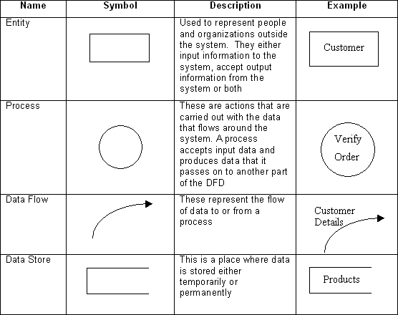

#### Fig 3.1: Data Flow Diagram Symbols

Department of Computer Science and Application , GLAU

Page No. 15

**Software Design**

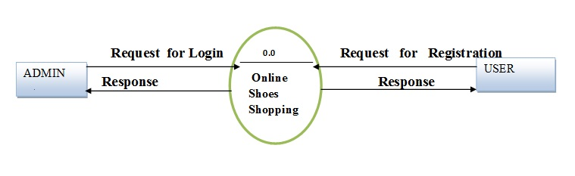

**Fig 3.2: O-Level DFD**

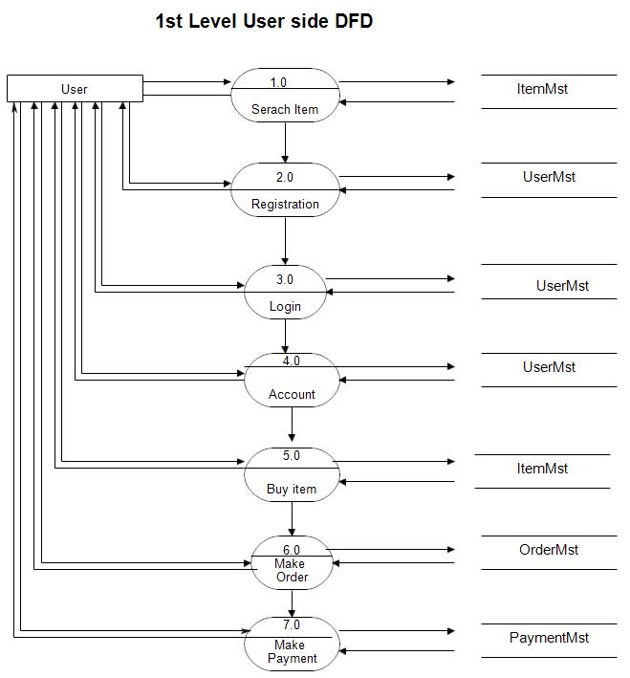

**Fig 3.3: 1 Level DFD**

Department of Computer Science and Application , GLAU

Page No. 16

**Software Design**

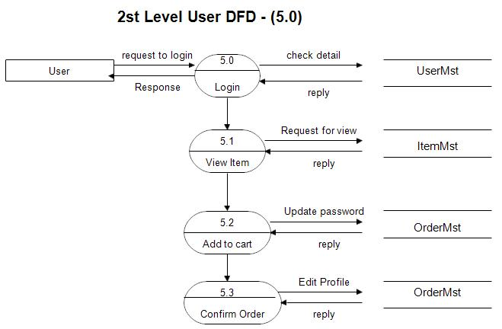

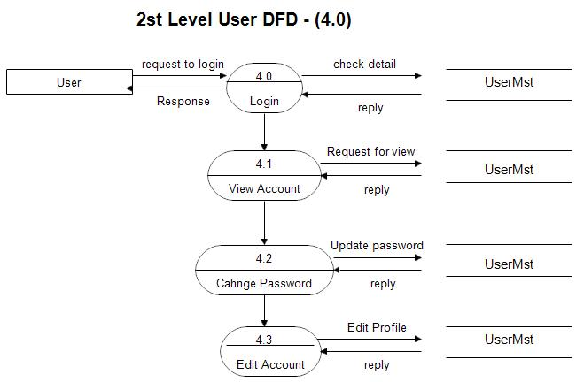

**Fig 3.4: 2 Level DFD**

Context level data flow diagram (dfd) is describe the whole system. The (o) level dfd describe the all user module who operate the system. Below data flow of online shopping site shows the two user can operate the system Admin and Member user.

Department of Computer Science and Application , GLAU

Page No. 17

* The user is all people who operate or visit our website. User is a customer of a web User can first select product for buy, user must have to register in our system for purchase anyitem from our website. after register he can login to site.

## 3.2 Usecase Diagram

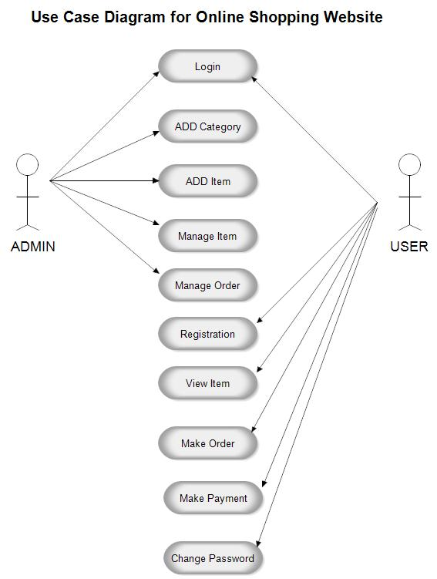

Department of Computer Science and Application , GLAU

Page No. 18

**Fig 3.5: Usecase Diagram**

**Software Design**

## 3.3Entity-Relationship Diagram(ER)

An entity-relationship diagram (ERD) is a graphical representation of an information system that shows the relationship between people, objects, places, concepts or events with in that system. An ERD is a [data modeling](http://searchdatamanagement.techtarget.com/definition/data-modeling) technique that can help define business processes and can be used as the foundation for a [relational database](http://searchsqlserver.techtarget.com/definition/relational-database).

While useful for organizing [data](http://searchdatamanagement.techtarget.com/definition/data) that can be represented by a relational structure, an entity-relationship diagram can't sufficiently represent semi-structured or [unstructureddata,](http://searchbusinessanalytics.techtarget.com/definition/unstructured-data) and an ERD is unlikely to be helpful on its own in integrating data into a preexisting information system.

Three main components of an ERD are the [entities](http://whatis.techtarget.com/definition/entity), which are objects or concepts that can have data stored about them, the relationship between those entities, and the [cardinality,](http://whatis.techtarget.com/definition/cardinality) which defines that relationship in terms of numbers.

#### Components of the ER Model

The three main components of the ER Model are **entities**, **attributes** and

#### relationships.

* In ERM terms, an entity is a "thing" within the organization that we want to keep information about, such as a customer, employee or course. Entities are represented by rectangles containing the name of the entity. Entity names must be singular and in capital letters.
* Each entity has attributes which are the properties of each entity.

Department of Computer Science and Appliccation GLA

Page No. 19

**Software Design**

* Attributes can be of various types. A composite attribute can be sub divided into smaller parts. For example, an attribute Name can be subdivided into First Name and Last Name. Attributes that cannot be subdivided are called simple attributes. First Name and Last Name are now simple attributes. Most attributes have only a single value and as such are called single valued attributes. For example, a Teacher can have only one Last Name or a Subject can have only one Subject Code. Multivalued attributes can have more than one value. For example, a Student could have more than one Certificate or a Department may have several Extensions.
* A key attribute is an attribute that has a unique value for each entity occurrence. In other words, a key attribute is used to identify each row uniquely.Key attributes are represented by underlining its name.
* A relationship is the association between entities or entity occurrences.

**3.4 Database Design**

* A good database design is crucial for a high-performance application, just as an Aerodynamic body is important to a race car. Thinking about relationships and database efficiency is part of normalization.
* Beyond the issue of performance is the issue of maintenance—your database should be easy to maintain. This includes storing only a limited amount (if any) of repetitive data. If you have a lot of repetitive data and one instance of that data undergoes a change ( such as a name change ), that change has to be made for all occurrences of the data. To eliminate duplication and enhance your ability to maintain the data, you might create a table of possible values and use a key to refer to the value

Department of Computer Science and Application , GLAU

Page No. 20

**Software Design**

.

**SQL database :**

**Users table:**

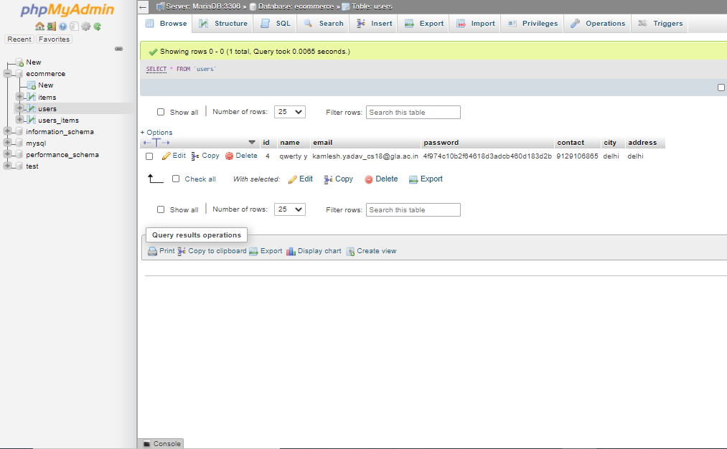

**Products table:**

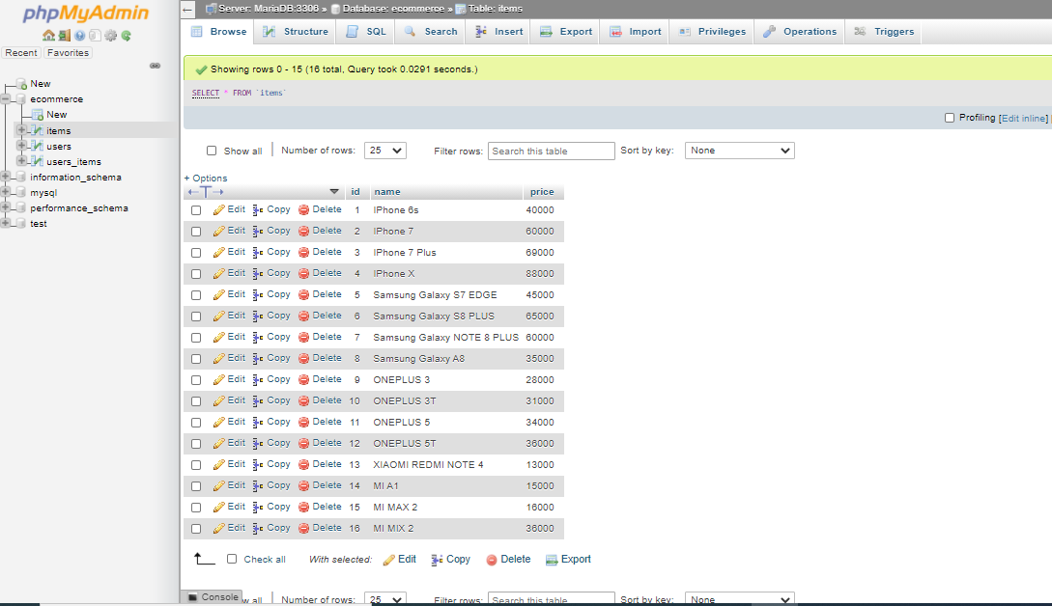

Department of Computer Science and Application , GLAU

Page No. 21

i

i

**Software Design**

**Users-Products table:**

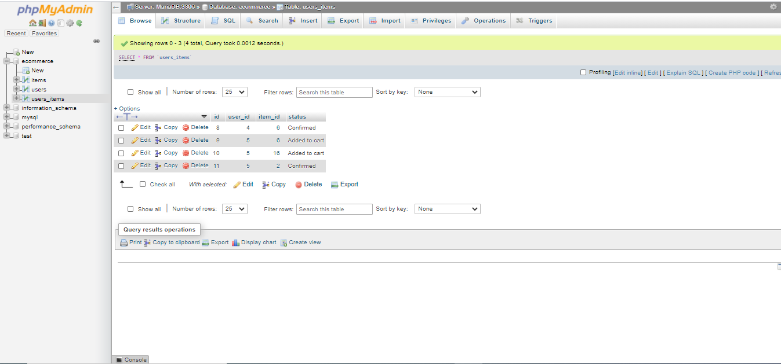

**PROGRESS REPORT**

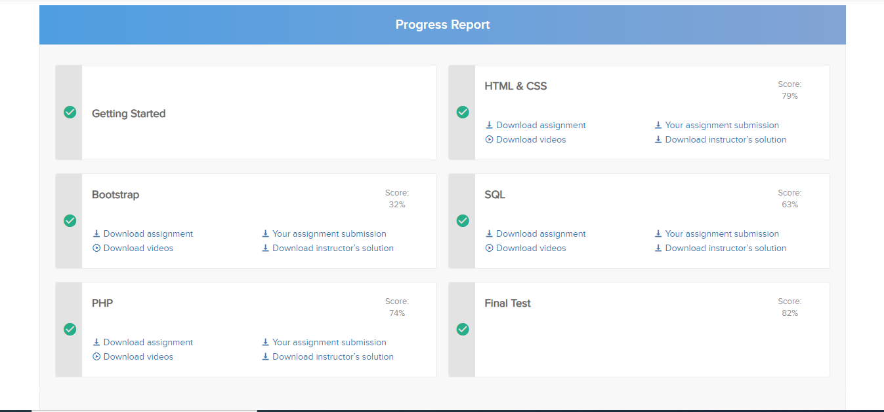

Implementation

Implementation & User Interface

**INDEX PAGE**

The index page is usually the first page when a user lands on any website. When a user first visits the items store website, he will see the following page.

Inorder to avoid the repetition of header(containing navbar) and footer(external links), their coding are written in different php files namedheader.php and footer.php and then these are included in all the pages of project.

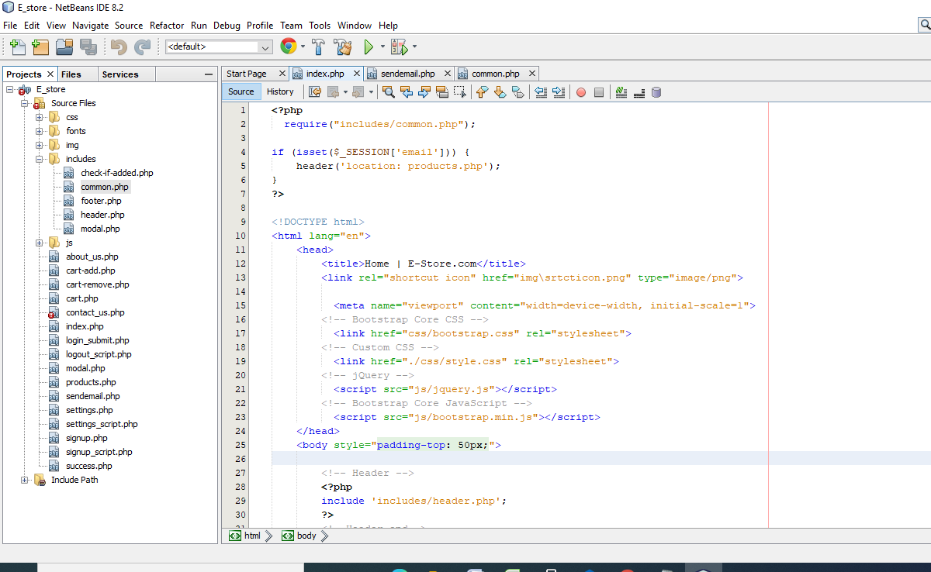

* the navbar ( fixed navbar at the top)
* Sign Upcontains the link to the signup.php page.
* About Us contains the link to the about.php page.
* Contact Us contains the link to the contact.php page.

Implementation & User Interface

**BODY**

Body contains the grid system with two rows and three panels made in each row. A panel in bootstrap is a bordered-box with some padding around its content. The panel-heading class helps to give a heading to content. The panel-body allows to write description whereas the panel-footer adds a footer to panel.

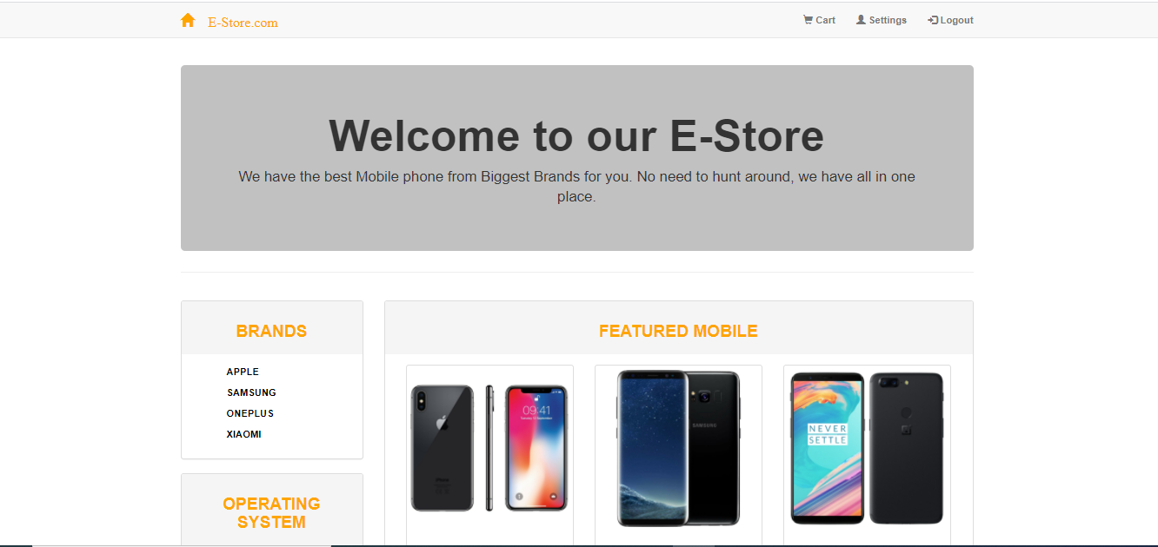



* In footer, My Account and Contact Us are text but beneath them all are links except the number below the contact us.
* The panels show specifications of various smart phones of different companies.

Department of Compuetr and application GLA

Page No.24

Implementation & User Interface

**ABOUT US PAGE**

The navbar and the footer areremain same. In the body section, one row is created which will have class container inside to make the row responsive and helps in the design of the web page. This row will be divided into 3 columns which will contain one panel each.

* First column introduces the e-commerce company.
* Second column talks about the history of company creation.
* Third column shows the opportunities provided to interns for various roles
* The header and the footer remains common at each page.

**ABOUT US LAYOUT:**

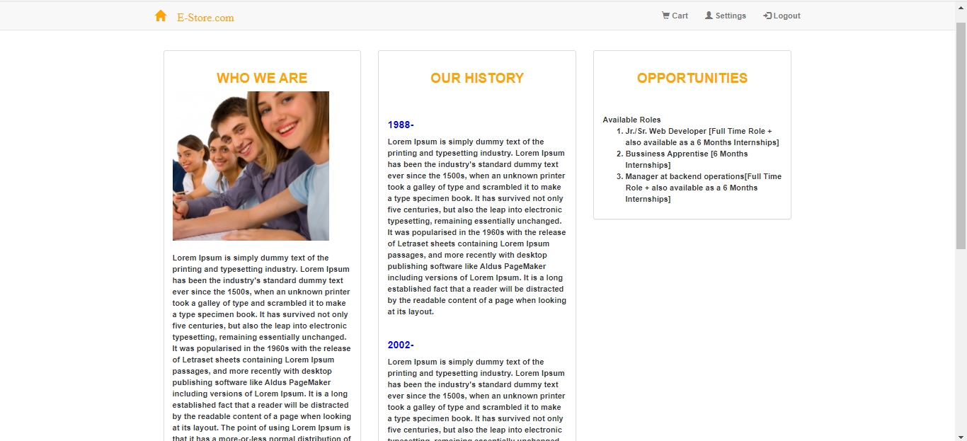

Department of Compuetr and application GLA Page No. 25

Implementation & User Interface

**CONTACT US**

* In the body section, two rows are created and both the rows will be divided into two columns using grid feature.
* First rowcontains live support section and the image.
* Second row will containthe contact us form and company information. The user will be able to input their name, email and message. Submit button sends the form to the server.

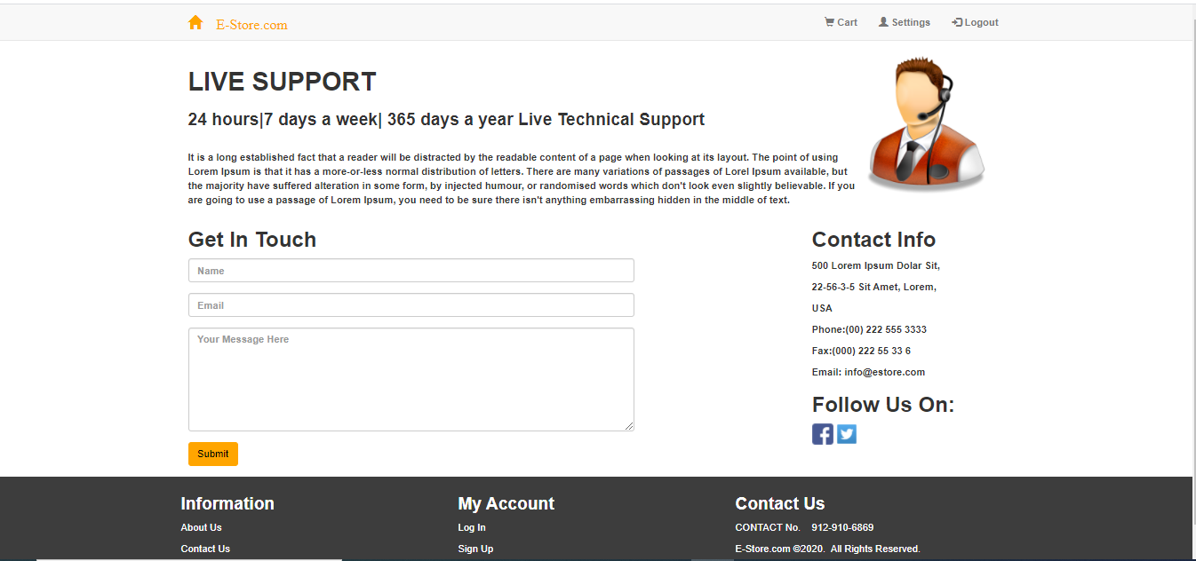

**SIGNUP PAGE**

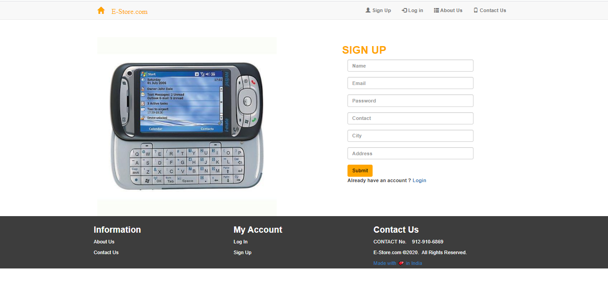

**Implementation & User Interface**

* On the signup page, new users can register using the ‘signup’ form and create accounts.
* Existing users canlogin using the ‘login’ modal.
* The signup form has six fields i.e. ‘name’, ‘email’, ‘password’, ‘contact’, ‘address’ and ‘city’.
* The backend or the functionality of the form,comprises of form validation.

**FORM VALIDATION:**

In order that the data entered by any user is considered as a valid input, we have to force the data to obey certain rules. We have listed the rules for this signup form as follows:

1) Each user on the website will be uniquely identified by his email id, so we must to ensure that no two users have the same email ids.

2) We must ensure that the user enters a valid e-mail address and not just any string.

3) We must ensure that a valid ten digit mobile number is entered by the user.

4) We must ensure that the user can submit the form only after he/she fills in all the fields.\

**CART PAGE**

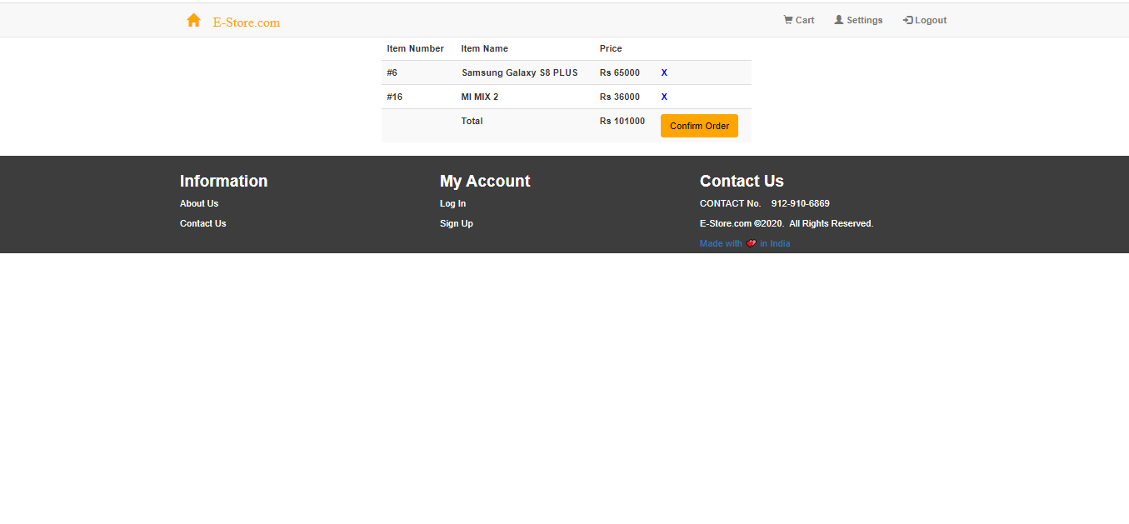

**SETTINGS PAGE**

* This page contains only one row. The row consists of one column containing a form.
* Here, form validation is implemented again.
* If the user enters different passwords in the fields ‘New Password’ and

**Implementation & User Interface**

* ‘Retype New Password’, a message is shown that the passwords don’t match. If the user enters the incorrect ‘Old’.
* ‘Password’, an error message is displayed indicating that he/she has entered the wrong password.
* If the user fills the three fields correctly, his/her password is updated.

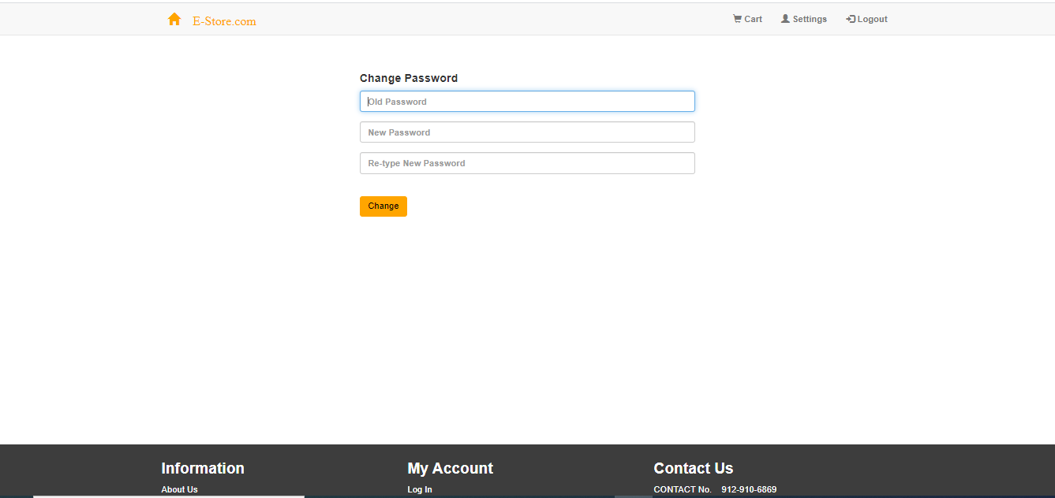

**SUCCESS PAGE**

The success page informs the user that his/her order has been accepted and his items would be delivered shortly.

* Also,there is a link to the home page where the user can purchase more items.

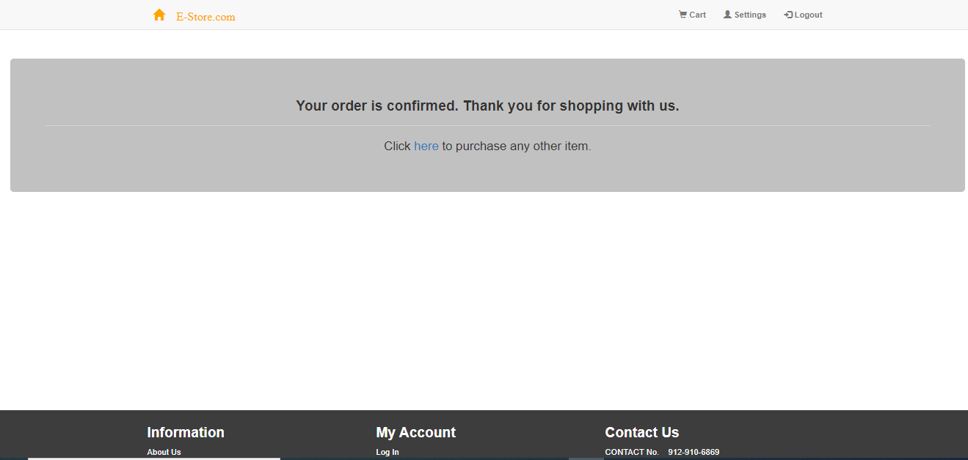

**CONCLUSION**

The above implementation resulted in basic ecommerce website where a user can sign up, login, buy products and receive acknowledgement for the same. Unless the user is logged in, he cannot go to the home page, the confirm page, the success page or the settings page. When he/she isn’t logged in and he tries to navigate to the above pages, he/she if redirected to the index page of the website. In this case, clicking on the logo from any page redirects

the user to the index page. Once the user is logged in, he/she cannot navigate to either the index page or the login page and is redirected to the home page. In this case, clicking on the logo from any page redirects the user to the home page.

It was an experience that changed the way I perceived project development. The project is a classic example, that learning of concepts needs to be supplemented with application of that knowledge, without which knowledge remains incomplete.

Department of Compuetr and application GLA

Page No. 29

**LIMITATIONS**

1. One of the most important limitations was the time period. Due to limited duration of this course, some of the topics weren’t studied in detail. Still, all the content was read totally and implemented.
2. This website is a small demo for explaining the working of a shopping website. It doesn’t actually consider all the points that are required in real for a website.
3. Payment option is not a part of this website.
4. Due to unavailability of an instructor guidance all the time, many doubts remained unclear. But, to some extent, the internet helped to pave a way out.

Department of Compuetr and application GLA

Page No. 30

**EXPERIENCE**

Overall experience of working on this project was good. It was quite interesting to see the things appearing on the front-end of the website with several validation codes running at the back-end. It was a project totally created by me, therefore I was able to develop my skills. Although I found it a bit challenging but exploring this domain was equally amazing.

The experience of working on Internshala was nice too. The course was so properly arranged into modules that learning part was made easier. The instructor responded timely on to all the queries. Also, there were frequently asked questions along with instructor’s solution posted on Internshala which were very helpful as a reference. The quizes, code challenges and exercises provided at the end of each section was helpful in testing my learning and correct the mistakes.

I am really looking forward to higher learning in this field and apply my skills for the benefit of the organization I’ll be working for.

Department of Compuetr and application GLA Page No. 31

**BIBLIOGRAPHY**

The coding part was implemented majorly with the help ofInternshala training course only.

<https://internshala.com/>

Other links referred were :

<https://www.w3schools.com/html>

<https://www.w3schools.com/css>

<https://www.w3schools.com/sql>

<https://stackoverflow.com/>

<https://beginnersbook.com/>

<https://www.color-hex.com/>

<https://www.w3schools.com/bootstrap/bootstrap_ref_comp_glyphs.asp>

CSS Link:

<https://maxcdn.bootstrapcdn.com/bootstrap/3.3.7/css/bootstrap.min.css>

jQuery Library:

https://ajax.googleapis.com/ajax/libs/jquery/1.12.4/jquery.min.js

https://maxcdn.bootstrapcdn.com/bootstrap/3.3.7/js/bootstrap.min.js

Department of Compuetr and application GLA Page No. 32